
STUDENT DETAILS:
Student Name: Kelvin Mein
Admission Number: BSCCS/2024/56078
Course/Class: Computer Science
Unit Code: BIT3208
Unit Name: Advanced Web Design and Development
Lecturer Name: Michael Nyoro
Semester/Academic Year: Year III Sem II
PROJECT DETAILS:
Project Title: Ecommerce System
Selected Technologies:
- HTML – page structure
- CSS – styling and layout design
- PHP – backend logic and dynamic content
- MySQL – database management
GitHub Link:
GitHub link:https:github.com/kelvinmein/OnlineEcommerceSystem
WEEK 1:LOCAL ENVIRONMENT SETUP 3
Fig 1 : Installation of XAMP 3
Fig 2:Apache and Mysql Running 4
Fig 3: Localhost test page 5
Fig 4: Hello World Test 6
Fig 5: Database Connection Test 7
WEEK 1 REFLECTION 7
WEEK 2: WIREFRAMES AND GUI DESIGN 8
Fig 1: Hand-drawn Wireframe 8
Fig 2: Dashboard Layout Design 9
Fig 3: Mobile View Mockup 10
Fig: 5 GUI Prototype in Canva 12
WEEK 2 REFLECTION 12
WEEK 3 JAVA SCRIPT AND PHP BASICS 13
Fig 1: Java script form validation 13
Fig 3: Syntax Practice 15
Fig 4: Database Connection Script 16
Fig 5: Dynamic User Input Handling 17
WEEK 3 REFLECTION 17
WEEK 4 PHP server side Development and deployment 18
Fig1:XAMPP control panel showing Apache services and MySQL running 18
Fig 2: Ecommerce System Homepage running on localhost 19
Week 4 REFLECTION: 19
WEEK 5 Creating and Querying databases 20
Fig 1 Creating database 20
Fig 2: Querying the database 21
Week 5 REFLECTION: 21

WEEK 1:LOCAL ENVIRONMENT SETUP

Fig 1 : Installation of XAMP
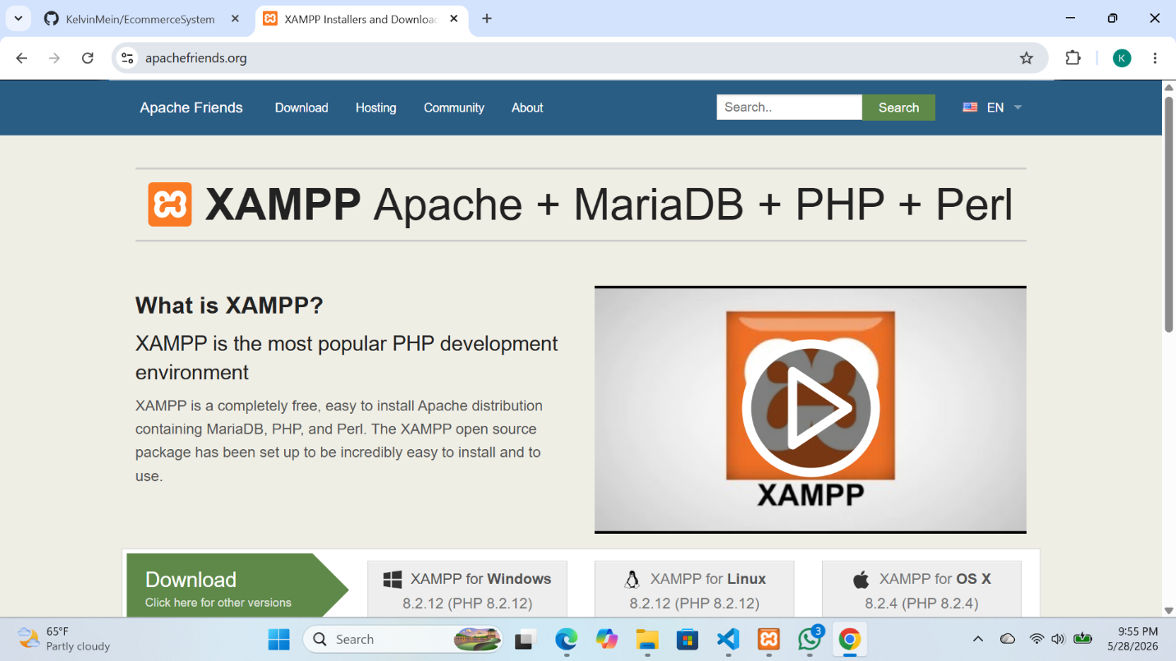

Fig 2:Apache and Mysql Running
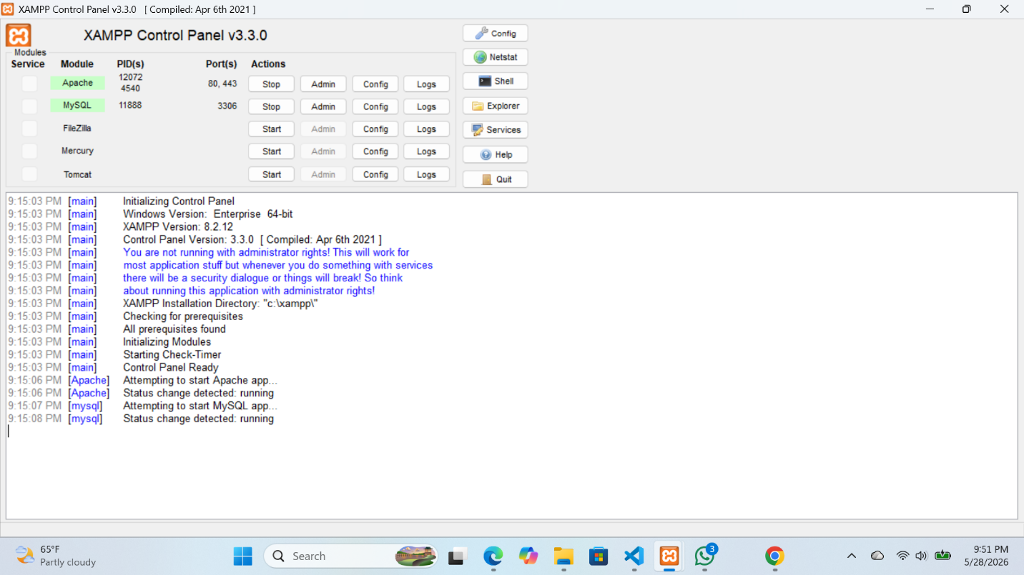

Fig 3: Localhost test page
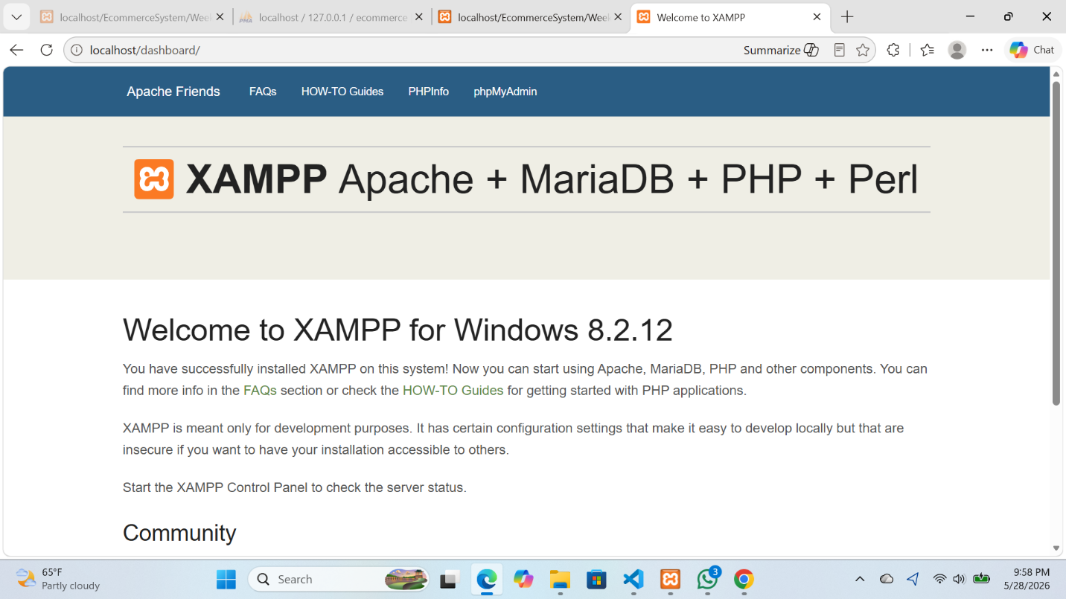

Fig 4: Hello World Test
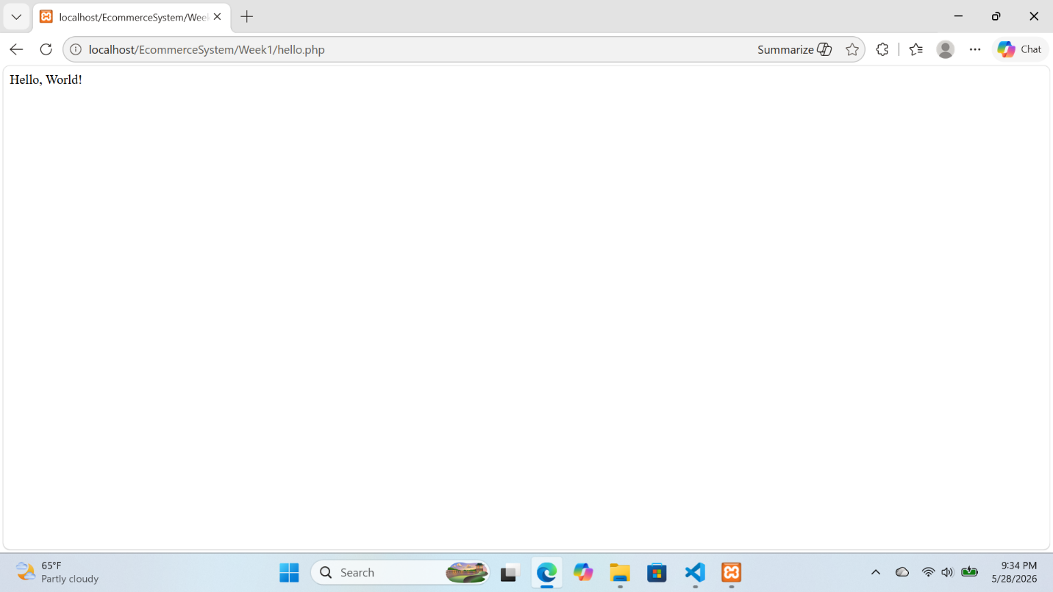

Fig 5: Database Connection Test
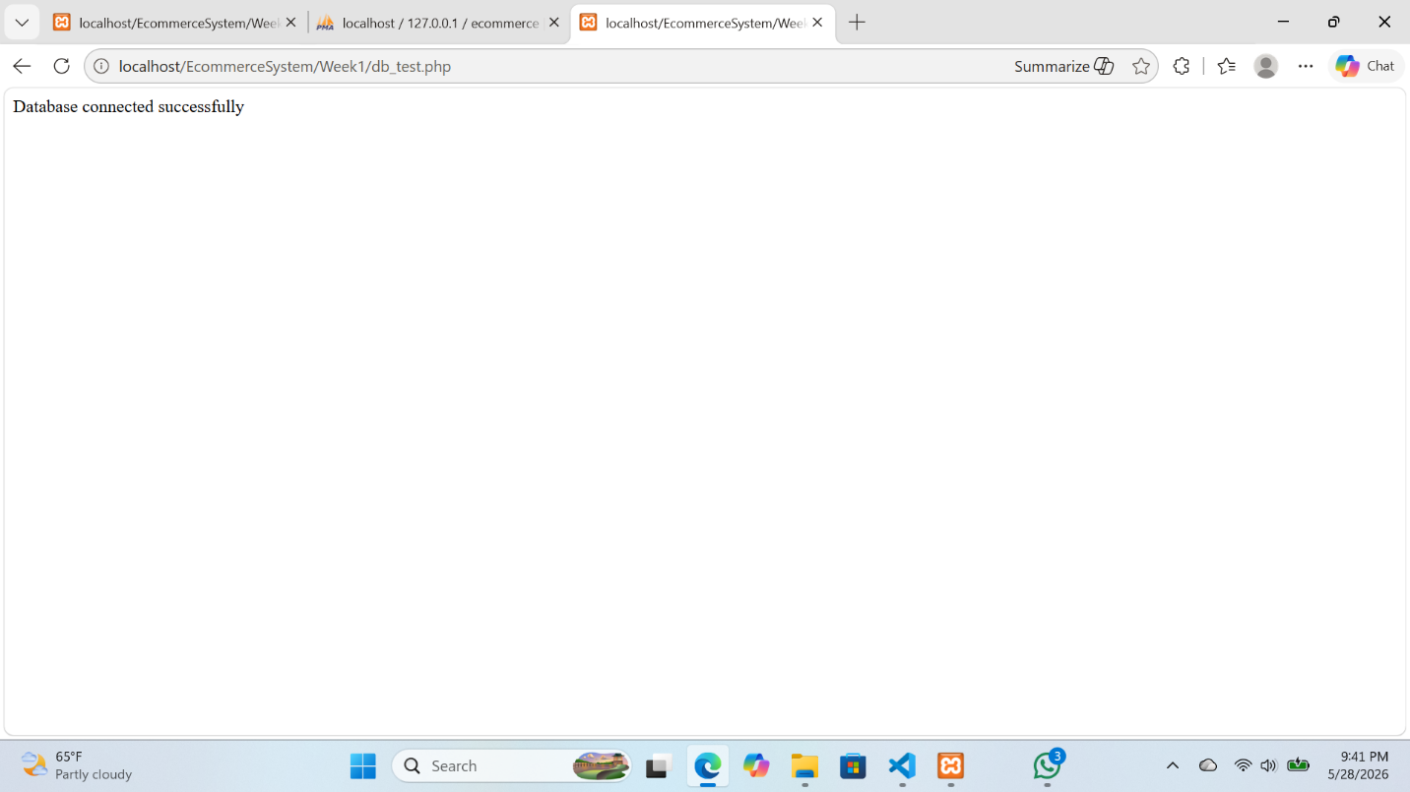

WEEK 1 REFLECTION
The project involves developing an E-commerce System using PHP, JavaScript, and MySQL. The system is designed to allow users to register, log in, view products, and manage a shopping cart. It also includes an admin section for managing system activities

WEEK 2: WIREFRAMES AND GUI DESIGN

Fig 1: Hand-drawn Wireframe
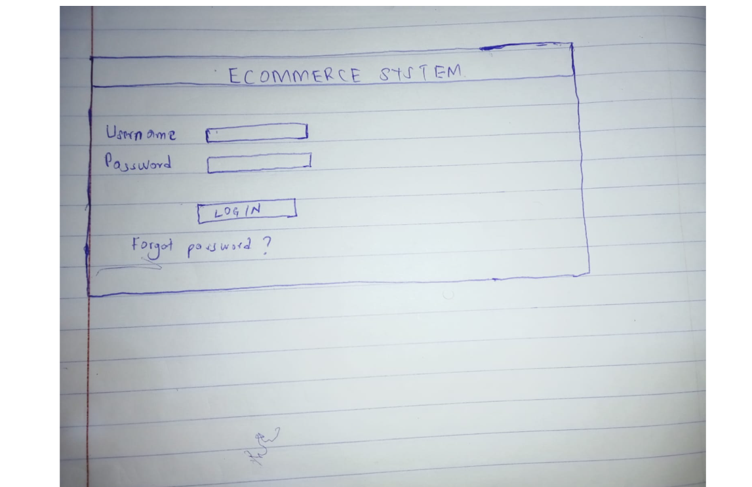
1SZsDdsdsdsdsd
‘\]\\

Fig 2: Dashboard Layout Design


Fig 3: Mobile View Mockup
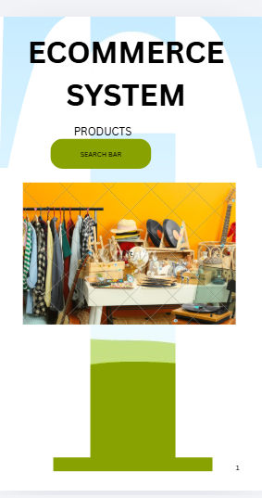

Fig:4 Color theme
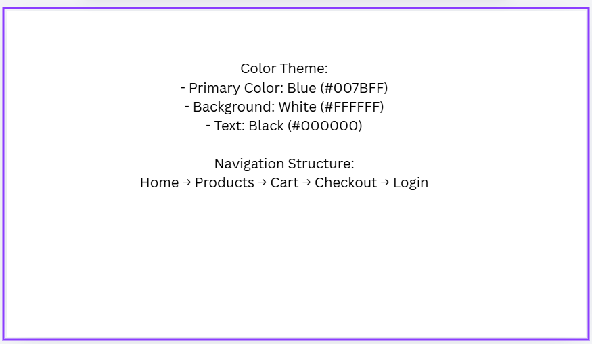

Fig: 5 GUI Prototype in Canva
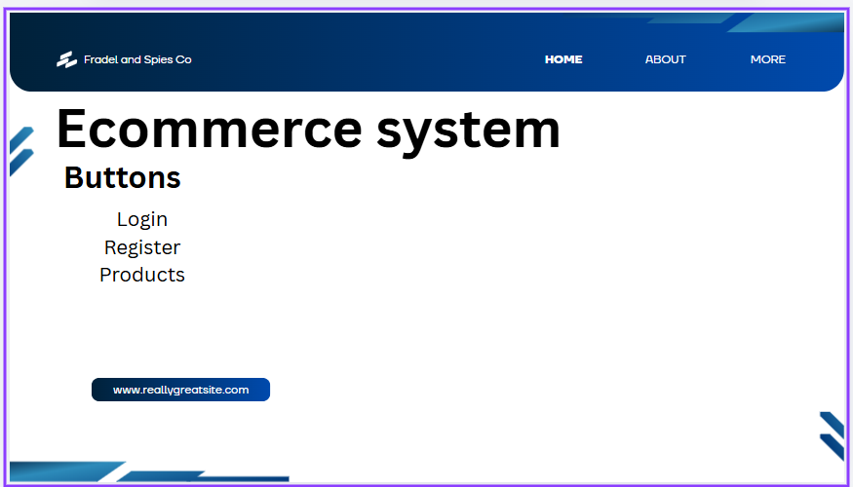

WEEK 2 REFLECTION
This phase focuses on designing the user interface (UI) of the E-commerce System. It involves planning how users will interact with the system, including layout design, navigation structure, and mobile responsiveness. The goal is to create a clear and user-friendly interface before actual system development begins.

WEEK 3 JAVA SCRIPT AND PHP BASICS

Fig 1: Java script form validation
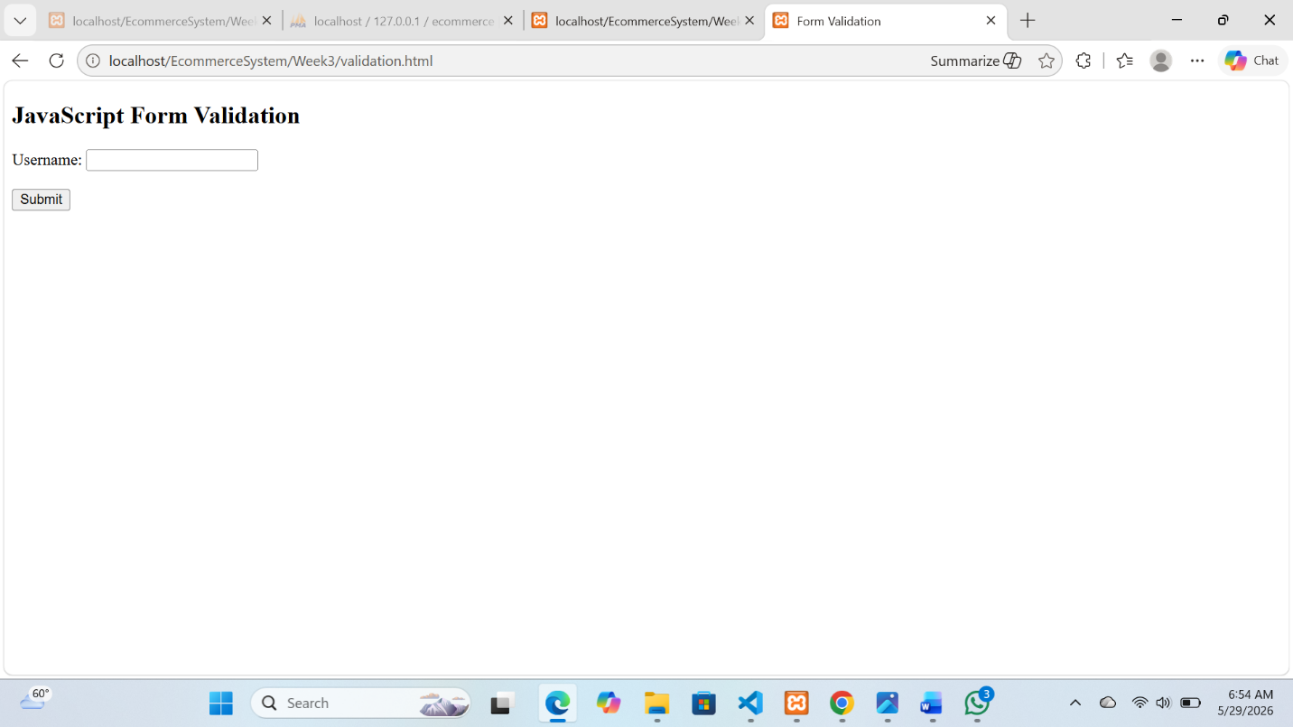

Fig 2: Password Strength Checker
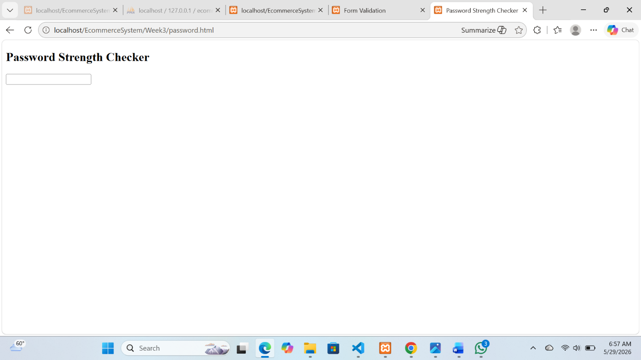

Fig 3: Syntax Practice
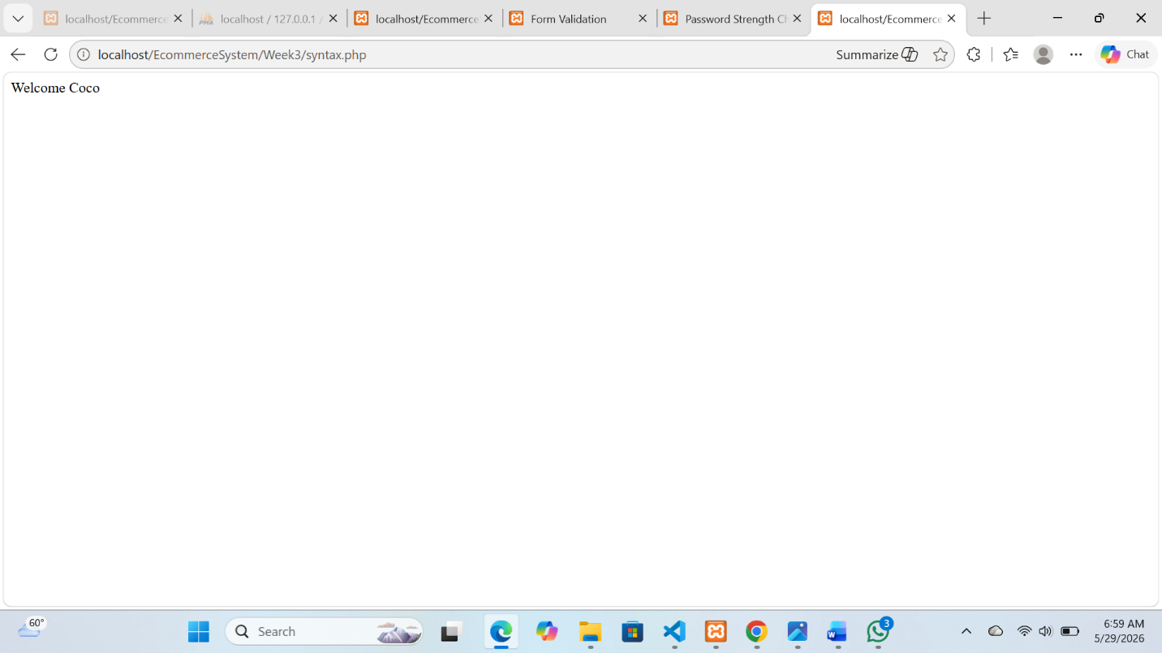

Fig 4: Database Connection Script


Fig 5: Dynamic User Input Handling
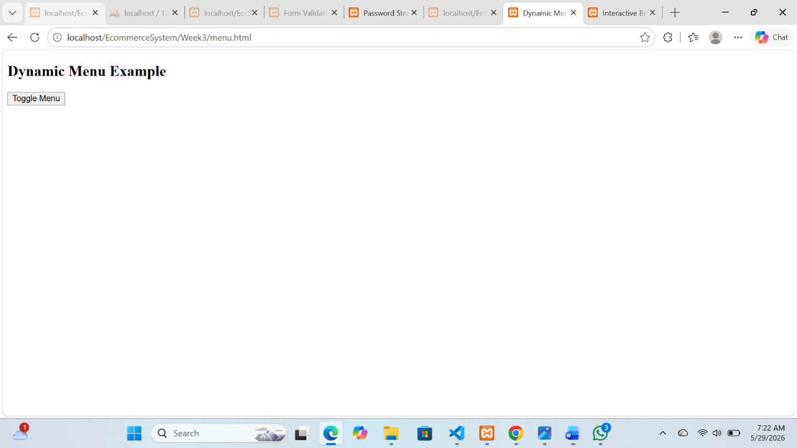

WEEK 3 REFLECTION
This focused on learning the basics of JavaScript and PHP integration to build interactive web pages and simple backend functionality for an e-commerce system.

WEEK 4 PHP server side Development and deployment

Fig1:XAMPP control panel showing Apache services and MySQL running


Fig 2: Ecommerce System Homepage running on localhost
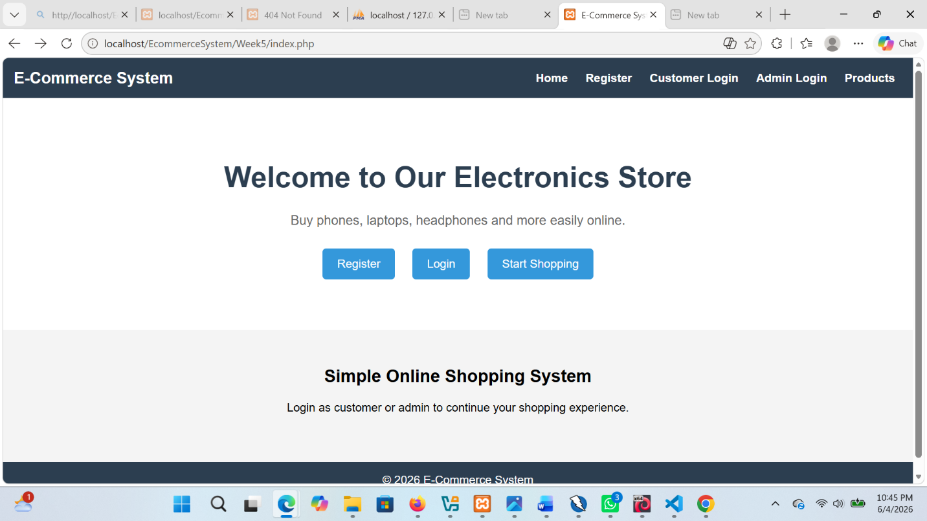

Week 4 REFLECTION:
In Week 4, I learned how to deploy a PHP web application using XAMPP as a local server environment. I started Apache and MySQL services and successfully ran my e-commerce system on localhost. This helped me understand server-side scripting and how PHP processes requests on a web server. I tested key pages such as the homepage, login, registration, and dashboard to confirm they were working properly. I also learned the importance of correct file paths in web development. Overall, I gained practical skills in setting up and running a PHP-based web application.

WEEK 5 Creating and Querying databases

Fig 1 Creating database
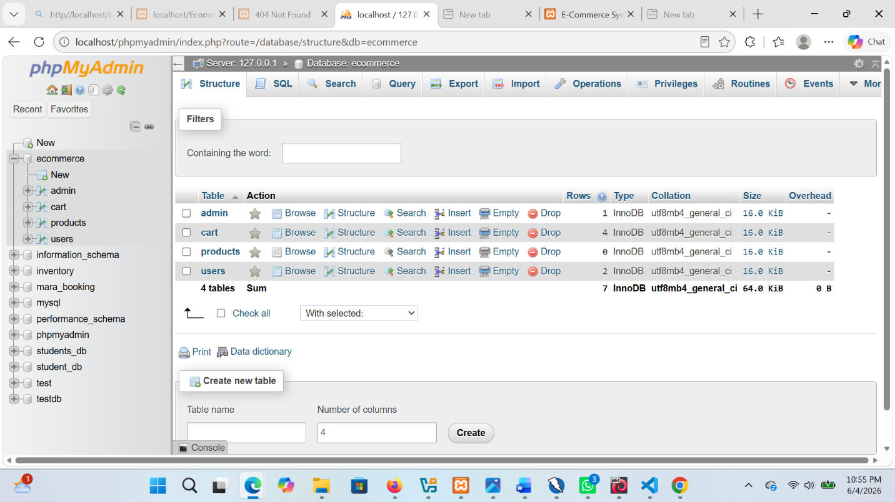

Fig 2: Querying the database
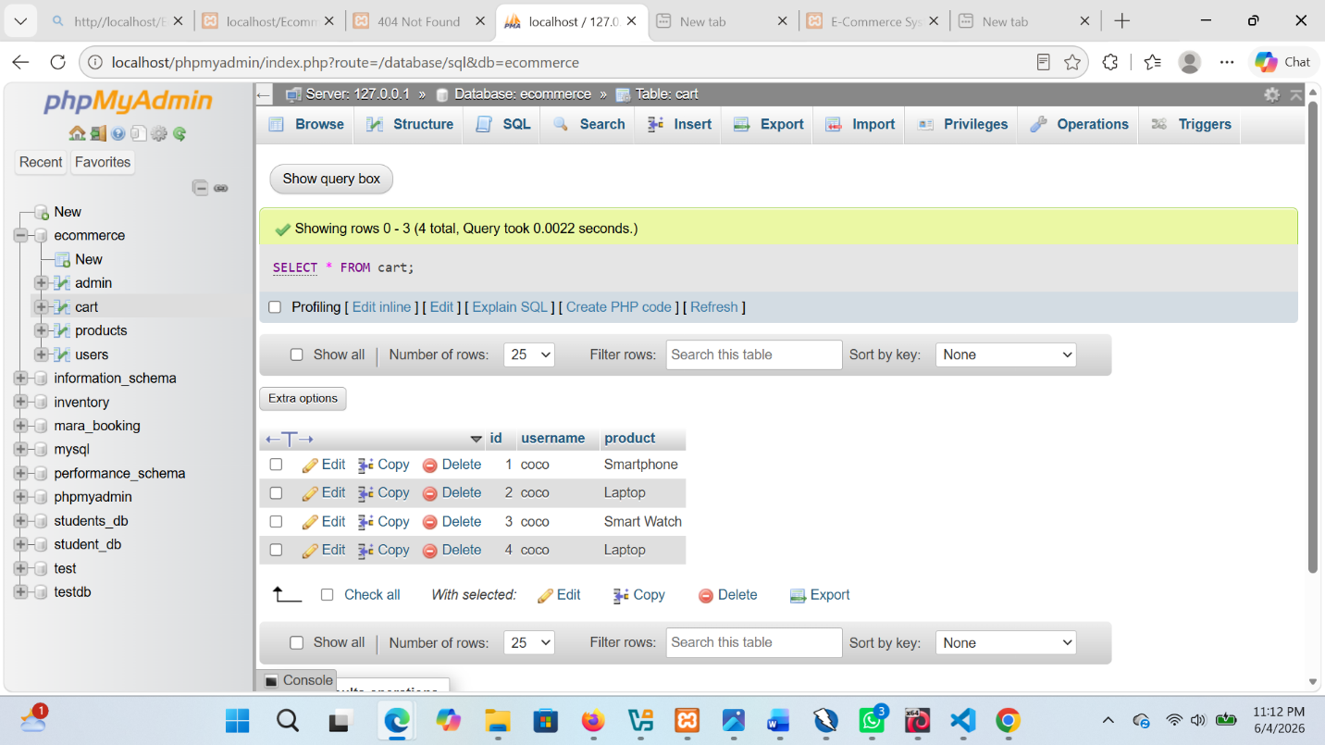

Week 5 REFLECTION:
I learned how to create and manage a database using MySQL and phpMyAdmin. I created tables for users, admin, products, and cart, and used SQL queries to insert and retrieve data. This helped me understand how web applications store and manage information. I also tested the database by adding sample records and confirming successful data retrieval.

